eProcurement Edits: BACK END

We need to have a post category for BRIEFING REGISTER + CLOSING REGISTER + APPOINTMENTS: These three must be selective and must not display in both Front End and Back End unless ticketed by either Super Admin or SCM Manager in the settings. If ticked or selected, they must follow the same bid creation workflow but without KEY DATES + CONTACT PERSON. It must only be the BID NUMBER + DESCRIPTION + DOCUMENT. Avoid a mismatch since the same Bid Number could be a title 3 times, the code must be able to notice that this is a different category.
If any of the three (BRIEFING REGISTER + CLOSING REGISTER + APPOINTMENTS) is selected, it must be on the NAV menu of this plugin so that it does not destruct the view of bids.

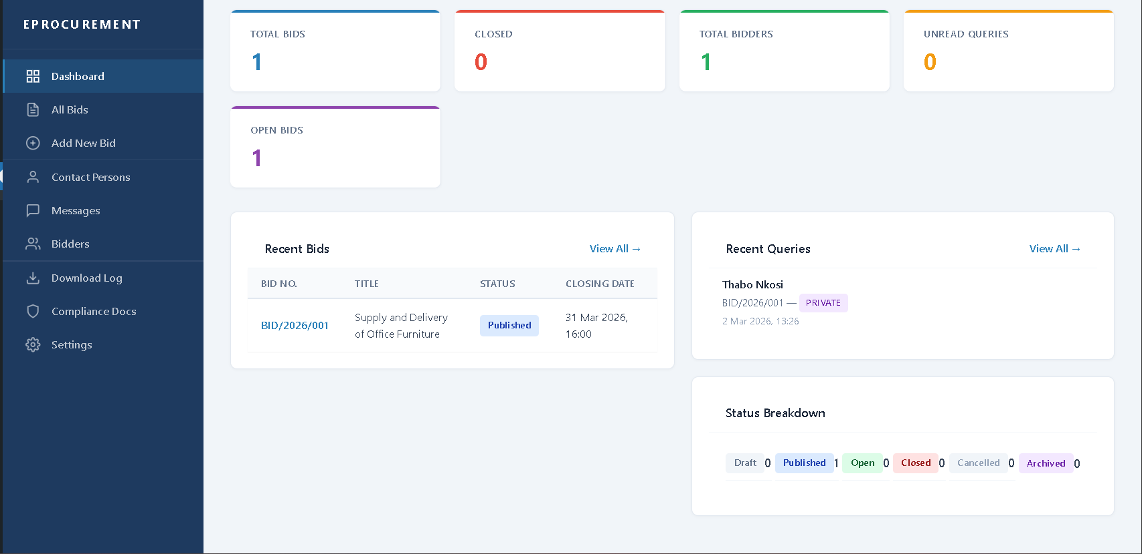
Include: Total Downloads by day + Most downloaded Document (on open documents only). The Status Breakdown as a duplicate of the top card, remove it.

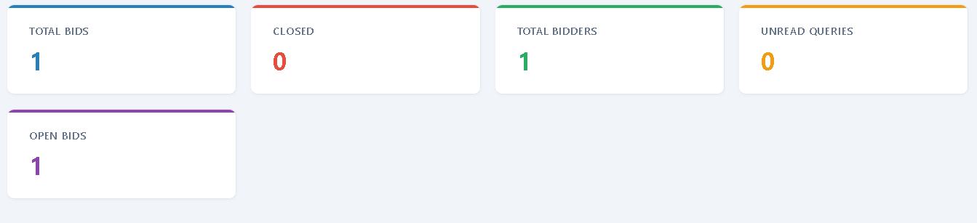
Make this card even

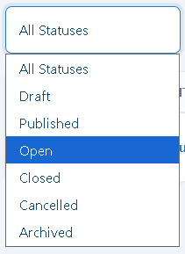
What is the difference between Open and Published statuses or bids?
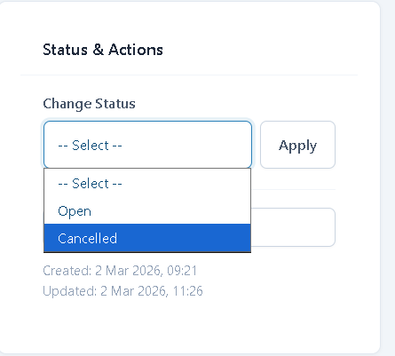There must be an Change Status option of CLOSE

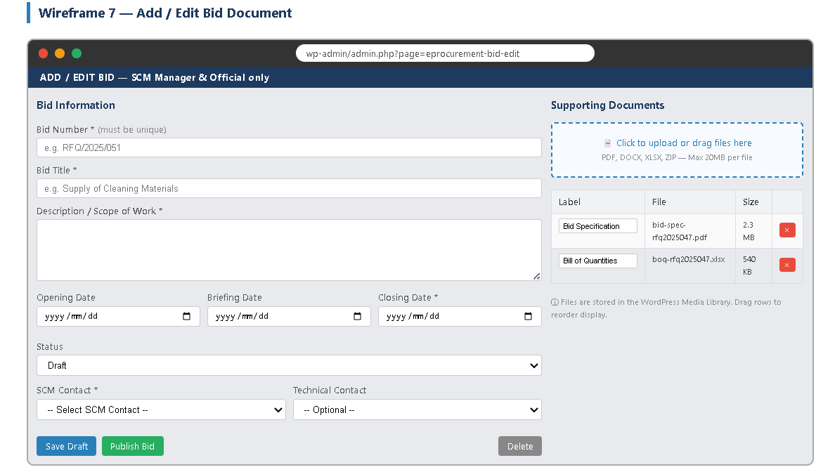I want this UI for Bids

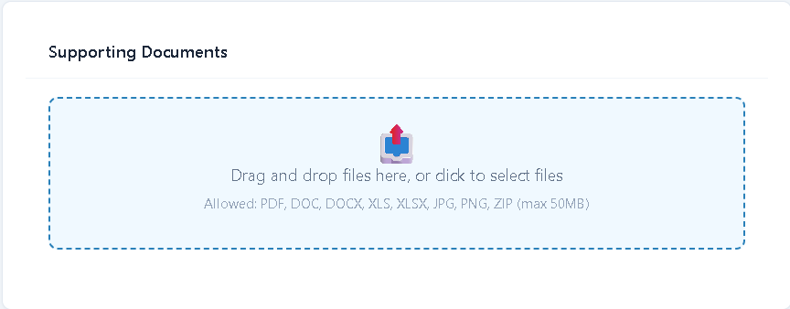I clicked here many times, and I was not directed anywhere. It is stuck. Also, change working from “Supporting Documents” to “Bid Documents”
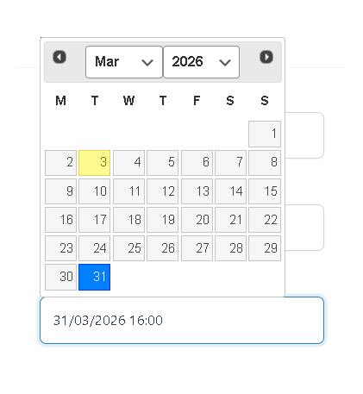We need to improve this UI and the time picker is not responsive.
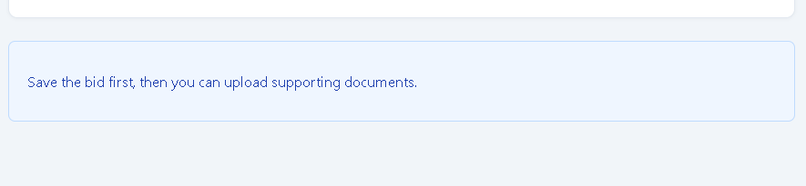This does not make sense, it only stretches the process. All interactions and settings must be able to be implemented on the Add Bid page, it must be the user that decides to save it as a draft.
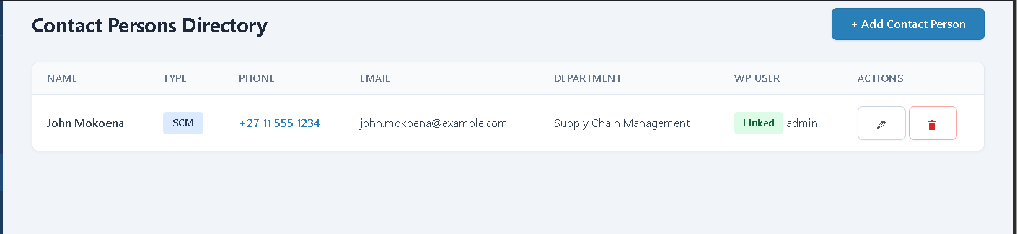We need a search bar here that enables search by Department also. By having the search bar, one can be able to toggle users of departments only only.
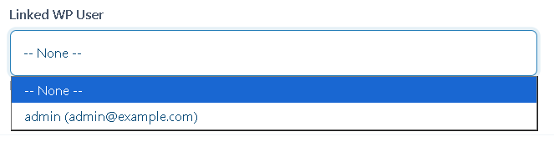The plugin must create a WP user by default whenever a user is created, this adds an unnecessary layer. Remember that the plugin has USER
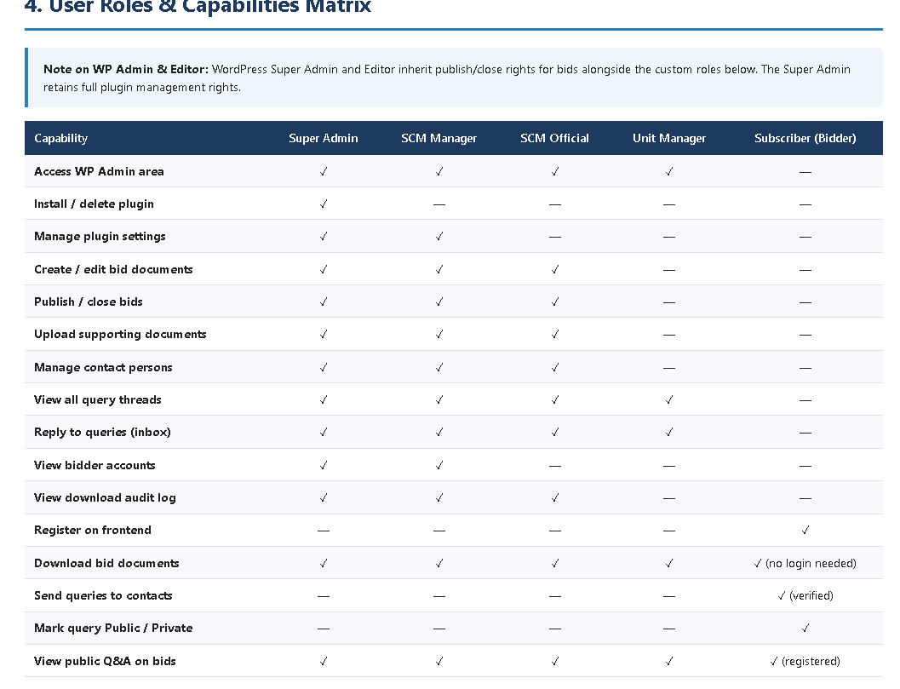Note that these are the capabilities and user roles

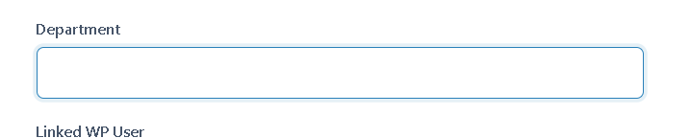There must be a drop down of these, only Super Admin and SCM Manager can edit, add, delete such, including default Editor role. The EDIT, CANCEL and CLOSE X button are stuck.
To assist chat responders with navigation, this title should redirect to the bid post, either by opening a new tab or an embedded view. But overall, it should not take a user out of the chat.
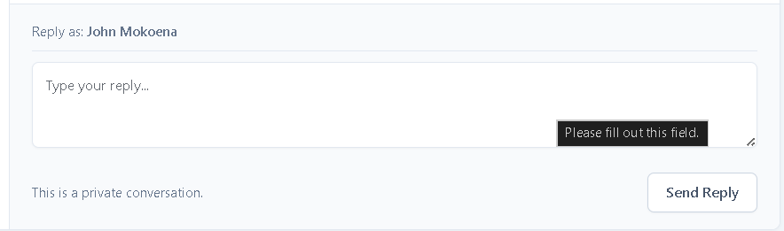Officials should be able to attach documents or jpeg images capped at 5mb
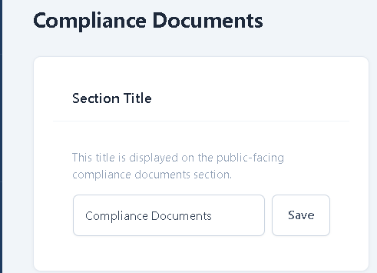Change from “Compliance Documents” to “SCM Documents” site wide
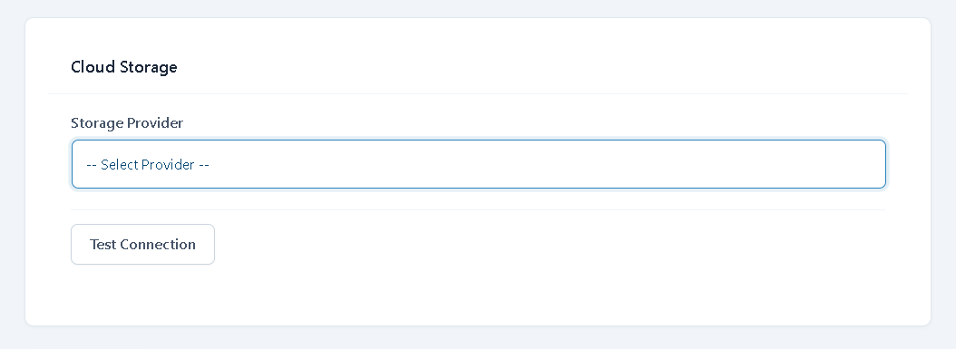This must only be visible to Super Admin. Every other user must not have any access to it, it must not even appear!

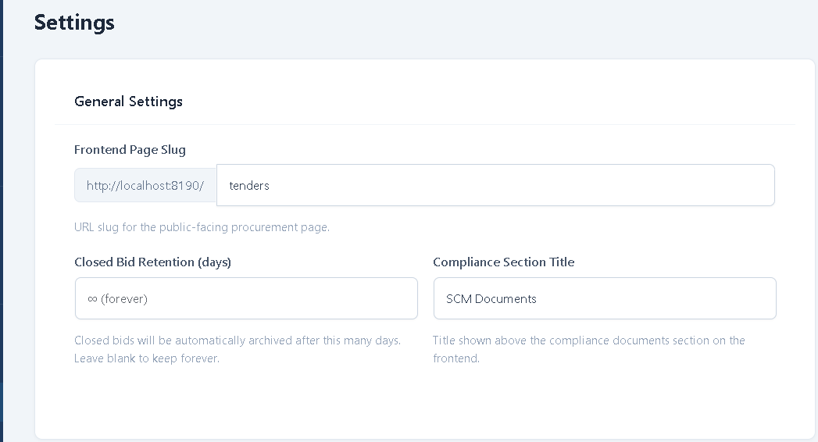We also need to have a shortcode of OPEN BIDS. Some other entities might want to display open/latest bids at their landing page, we must be prepared for this. You can even enable the creation of Shortcodes for Open and Closed bids.

